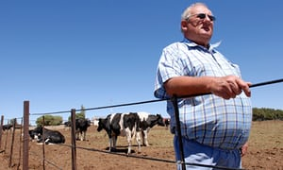
Persona One

- First Name : Frikkie
- Last Name : Srydom.
- Age : 51.
- Gender : Male.
- Occupation : Farm foreman.
- Residential Area : Skaapskraal .
- Roles and Responsabilties : Frikkie is a farm handler and as his work requires him to do stock control and water management , He is a father of six , whom still needs to provde for four of his six dependants .Frikkie thrives to bild a better livly hood for him and his children daily
- Pains : the Water shortage in the western cape has spiked a rise in the price per liter of water , due to this his month expenses have . His boss now requiers he lessesn the expenses , but holds the standard of productivity .
- Goals : He strives to for provide his family , and uphold or better there current standard of living . He’s work objectuves are to keep things running smoothly . And produce a grade fruit and veg.
- Media : Radio , televison , word of mouth and the the computer his eldest son bought him as a gift .


Persona Two
- First Name : Zihko
- Last Name : Mabenea
- Age : 24
- Occupation : Call Center agent at amazon
- Gender : Female.
- Residential Area : Belleville South
- Roles and Responsabilties : She is a Young Independat Woman in the heart of cpt striving to make a life fir her self , she lives with her high school Friend Jess. Togther they share Rent and utilities such as water elcetricty ect.
- Pains : Zihko is the only one in the house hold with a stable income as her FlatMate is still studying and only works part time . They can no longer afford the high tarrifs and are forced to make adujsments to the water ussage .
- Goals :to maintain a standard of living that is comfortable and desirable to her and jess.
- Media : smartPhone (twitter , facebook ,whatsapp and other forms of social networks ), laptop ,televison and radio.

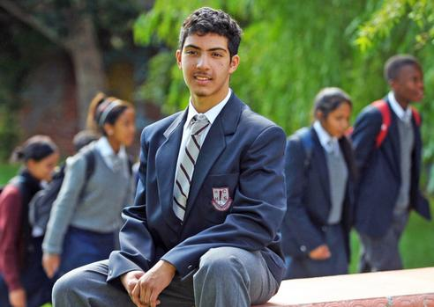
Persona Three

- Last Name : Raleph
- First Name : Richard
- Age : 17
- Gender : Male
- Occupation : Student Grade 11
- Residential Area : Platterkloof
- Roles and Responsabilties :Richard is a member of his schools honor society , as such they grow Fruits and veg that they use in the soup kitchen every tuesday . He is also the captain of the schools swimming team .
- Pains :due to water rstructions they cannot produce optimal fruit and veg ,and most of the fruit doesnt grow to optimal size , this applies stress to him and the rest of the students, and students who depend on the meal now fall short and do not get any meal for that day . As the Captain when the team underperfome the stress is put upon him .as his teamates cannot practise due to water restrictions
- Goals : He wants to uplift the overall moral of his fellow students as well making sure they have the correct nutrion needed for a day of learning . He works hard to bring the swimming team to national level once again and bring the trophy back one more time .
- Media : smartPhone (twitter , facebook ,whatsapp and other forms of social networks ), laptop ,televison and radio.

